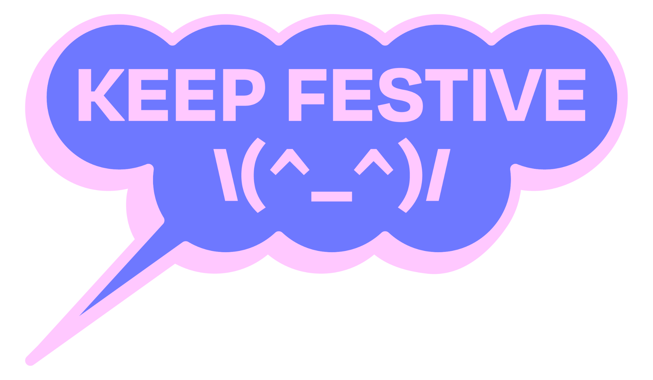

**Contents**

1. **What we stand for: Our Commitments**
2. **What we talk about: Definitions**
3. **What we guarantee: Minimum requirements**
4. **What we promote: Recommendations**
5. **How we act: Case management**
6. **What we assure: Principles of action**  
     
   Annexes:  
   *1. standard form „case assessment“  
   2. standard form „declaration of confidentiality“*

*3. complaint form example*

**1. What we stand for: Our Commitments**

The Keep Festive initiative was established to ensure a safe and inclusive atmosphere at festivals and events.

The goal is to provide a friendly, supportive, and harassment-free environment for everyone, regardless of gender, age, sexuality, physical appearance, ethnicity, religion, beliefs, or any other group identity.

Here are the guidelines for all participants at festivals and events:

All participants are expected to respect these guidelines and not to assume consent: **no** means **no** in all interactions. Everyone has the right to self-determination. There should be no generalizations or assumptions made about anyone’s background, experiences, gender, or sexuality. Participants should understand that everyone comes from different backgrounds and experiences, and while disagreements may arise, respectful interactions are essential. Everyone must take responsibility for their words, actions, and failures, and sometimes, offering an apology is necessary.

This Code of Conduct is one step in a global concept of care that Keep Festive is aiming at to build competencies, identify typical risks, improve professionalism in handling cases and prevent unwanted behaviour.

As that process is ongoing, this Code of Conduct is open to evolution and improvement and is to be seen as a fluid document.

**2. What we talk about: Definitions**Personal coverage:

This Code of Conduct applies to all festivals and events involved in the initiative. Participants include staff, volunteers, attendees, performers, speakers, filmmakers, partners, sponsors, and any other guests or individuals who interact with the festival or event in any capacity.

Material coverage:

Keep Festive declares the following forms of conduct as inappropriate and unwanted at festivals or events: threatening, discriminatory, disrespectful or harassing behavior. This includes, but is not limited to, physical or verbal abuse misconduct, sexual assault, unwanted sexual attention or advances stalking, and bullying.

At every participating festival or event, a designated person should be available to receive reports of unwanted behaviour. All reports will be taken seriously and must lead to concrete actions, with case management handled as outlined in this Code of Conduct. Cooperation is expected from everyone, and organizers will actively monitor and address these issues throughout the festival or event.

**3. What we guarantee: Minimum requirements**

Festivals that agree with Keep Festive’s Code of Conduct are expected to::

* place the Keep Festive logo and a short description on the official website, including information about adhering to Keep Festive guidelines;
* publish and communicate this Code of Conduct ( adapted as needed ) as part of the festival or event regulations , both before and during the event;
* provide information on how to report an incident before and during the festival or event through various means (e.g. posters, coasters, flyers, on-screen signage);
* designate at least one person of trust with special competencies in discrimination topics during the festival or event, and publicly provide their contact details (telephone number, email address);
* manage reports according to the principles described in point 5. and 6 of this Code of Conduct.

**4. What we promote: Recommendations**

In addition, Keep Festive recommends the following activities to enhance participant safety and prevent unwanted behaviour:

* develop procedures to promote the acceptance of this Code of Conduct by specific participant groups (e.g. presenting the Code of Conduct in preparation sessions);
* implement additional measures to disseminate this Code of Conduct before the festival or event (e.g. including key sections in invitations to guests, jury members, and agreements with sponsors, partners);
* implement additional measures to disseminate information about Keep Festive;
* train staff (especially management and designated trust persons) and volunteers on discrimination topics, prevention of unwanted behaviour, and professional management of reports.

Each member may implement those activities in accordance with their organizational and technical capabilities.

**5. How we act: Case management**

Involved persons when it comes to a report:  
- reporting person (RingP)  
- reported person (RedP)  
- trust person (TP)

- responsible person (ResP) (a person from the event leadership)

First steps after a report:

* the person receiving the report informs the Trust Person (TP) or, if the TP received the information directly, a Responsible Person (ResP). Together, they decide on an appropriate intervention team to handle this report;
* the intervention team must be constituted by the next day at the latest. The team should consist of at least three persons, two-thirds of whom are specially trained, with one member from the festival or event (ResP).

Tasks and next steps of the intervention team:

* analyzing the case using the “standard form case assessment“ (Annex 1) to determine the severity of the report and the urgency of immediate measures needed to ensure the safety of the Reporting Person (RingP);
* decide on the necessary immediate measures to guarantee safety of the RingP;
* provide the RingP with information about counseling institutions and state authorities for additional reporting if desired;
* focus solely on the content of the report without taking active investigation steps or contacting other concerned persons;
* decide on appropriate measures and consult the RingP to consider their opinion;
* adapt and undertake the necessary measures as needed;
* regularly inform all involved persons;
* document the report and the measures anonymously.

Possible measures (standard steps that need to be selected and adjusted individually):

* System Warnings: these may be necessary in every case, such as providing general information about the Code of Conduct regulations to participants of a workshop or venue;
* Informing the RedP: Notify the Reported Person (RedP) about the report and listen to their statement. Have the RedP sign a declaration of confidentiality;
* Discuss Participation: Evaluate the RedP’s participation in the event, including duration and activities;
* Explain Code of Conduct: Clearly explain the Code of Conduct to the RedP and request their adherence throughout the event;
* Confirm receipt of CoC: Ask the RedP to sign a confirmation receipt and acknowledgement of the Code of Conduct;
* Attention-Grabbing Tactics: Maintain heightened communication with the RedP and RingP during the event. Track the scheduled events and involvement of the RedP and RingP;
* Measures during the event: Increase communication with the RedP and RingP, monitoring their involvement and participation throughout the event;
* Partial Exclusion: Exclude the RedP from certain parts of the event, especially those involving the RingP;
* Complete Exclusion: Exclude the RedP from the event entirely if necessary.

**6. What we assure: Principles of action**

**Urgency:**

Given the short duration of festivals and events, we ensure immediate action following a report, including forming an intervention team to address the case within 24 hours.

**De-escalation:**

Measures should guarantee a safe space and care policy for Reporting Person (RingP) while also giving the Reported Person (RedP) an opportunity to explain and, if appropriate, apologize. .

**Transparency and confidentiality:**

Balancing transparency and confidentiality is crucial in handling reports, with the following main goals:  
- encouraging secure and confidential reporting;  
- building confidence, especially among those involved;  
- preventing further unwanted behaviour;  
- discouraging rumours and gossip.  
  
Keep Festive participating festivals act transparently regarding:

**Commitments and standards defined in this Code of Conduct:**

- Defining unwanted behaviour;  
- Principles and procedure for handling cases, including standard case management steps (excluding specific measures in individual cases);  
- Regular updates on the state and outcome of case management to all persons involved.

**Confidentiality:**  
- Reporting persons are guaranteed anonymity in case management;

- The “need to know“ principle: Only those necessary for the specific case are informed, as decided by the intervention team;

- Persons involved in a case must maintain confidentiality, except for discussing with individual trusted persons for personal relief (as outlined in Annex 2);

- Information necessary to calm concerns, avoid rumours, and prevent toxic dynamics is shared with solidarity and clarity, using minimal personal information;

- Case documentation should be conducted anonymously, with no names of RedPs given to third parties or listed for future events. If a report is made concerning a future event, an intervention team will be formed to process the standard case management.

***Annex 1***

***Standard Form Case Assessment for evaluating a report***

| ***Categories*** | *Sexual Harassment:*   1. *Verbal:*  * *Requesting sexual favors* * *Expressing a desire for sexual contact or conduct* * *Using sexually-explicit language* * *Telling sexual jokes* * *Commenting on a person’s appearance* * *Speaking in a sexual tone* * *Using sexually-suggestive nicknames or terms of endearment*  1. *Non-Verbal:*  * *Exposing oneself* * *Blocking a hallway or doorway* * *Blowing kisses or winking* * *Showing sexually-explicit videos* * *Staring, following, or stalking*  1. *Physical:*  * *Any form of unwanted touching* * *Patting, grabbing, rubbing, or pinching* * *Hugging or kissing*   *Discrimination based on:*   * *Age* * *Alienage* * *Disability* * *Gender* * *Marital Status* * *National Origin* * *Race/Ethnicity* * *Religion* * *Sexual Orientation* | | | | | |
| --- | --- | --- | --- | --- | --- | --- |
| *Frequency* | * *one-time, involving one RingP* * *one-time, involving multiple RingPs* * *repeated incidents, involving one RingP (short duration or longer duration)* * *repeated incidents, involving multiple RingPs and one RedP* * *structural (sexualized) violations* | | | | | |
| *Asymmetry characteristics* | * *privileged vs vulnerable group* * *hierarchies (roles, interdependence, etc.)* * *other status differences* | | | | | |
| *Behaviour* | * *mild breach of respectful behaviour/personal limits* * *intentional violation* * *assault* | | | | | |
| *Status of concretion* | * *proven* * *reasonable* * *vague* * *unsubstantiated* | | | | | |
| *Is there knowledge of an actual conflict between the RingP and the RedP?* | | | | | | |

***Annex 2***

***Standard Form Declaration of Confidentiality***

*Agreement between……………………….…………….……………………..….. (name of reported person, RedP) and intervention team (name of organization)…………………………..…………………………………………………………….*

*This declaration of confidentiality serves to protect …………………..……….. (name of RedP), reporting persons, and of……………………….………. (name of organization) from rumours and reputational damage.*

*We agree to the following terms:*

* *The intervention team……………………………………….(name organization) is responsible for managing the case intervention.*
* *…………………………….(name RedP) refrains from taking any private steps or conducting investigations.*
* *…………………………..…….(name RedP) treats all aspects of confidentiality.*
* *The intervention team…………………………….(name organization) treats the case confidentially and anonymizes……………………………………(name RedP) as muchas possible.*
* *……………………………… (name RedP) may discuss the case with trusted individuals, ……………………………..(name RedP). This means they may only discuss the case with …………………………..(name RedP) or the intervention team ……………………………(name organization ).*
* *If…………………………….(name RedP) becomes aware of third persons discussing the case, they will inform the intervention team………………………………(name organization).*